Lab 05: Reversing and Using an Undocumented API

CYBR 688: Software Reverse Engineering

Team Members: Sairam Bokka, Ethan Hart

Introduction
In this lab, we have two files to work with. One is an executable file called play and a shared object file called libconnect4.so. We must do static and dynamic analysis on these two files to understand the structure of the given API. We will document every function that we discover and write a software component that will communicate with the API to play tic-tac-toe instead of connect4. Through this, we hope to gain a better understanding of how to use static and dynamic analysis to take apart an executable and create components for it without ever having access to source code.

Materials
- AMD64 system (Ubuntu 24.04 used for this lab)
- A reversing tool that can perform static or dynamic analysis
- Provided source files for the lab

Procedure:
Understanding how the executable works: 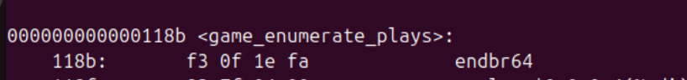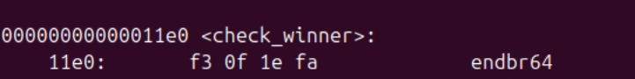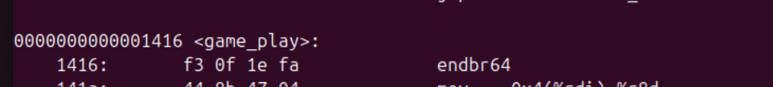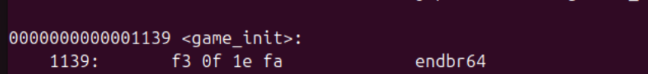
Here, we can already see some of the functions in libconnect4 that make sense to be used in the gameplay.

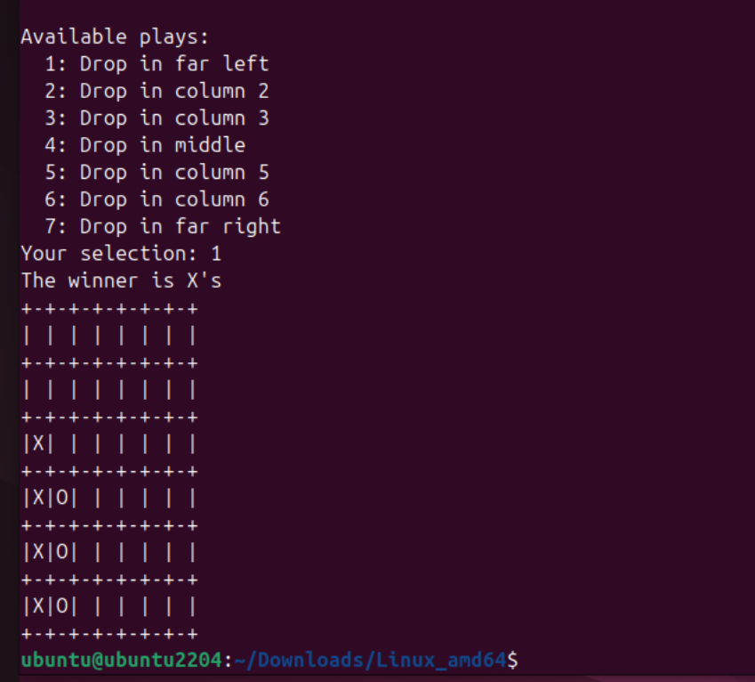

- We can see that it is a connect4 game where we must connect 4 ‘X’ or ‘O’ to win the game.
- The game has 7 possible move descriptions that are decreased if the move is not possible anymore.
- It does not accept any invalid move or invalid input.
- The game can end with either side winning or a draw.

Reverse Engineering the API:
- For this lab, we will use Ghidra with the gdb debugger for both static and dynamic analyses.
- We will look at the libconnect4.so with objdump to get started and look at some of the functions in the API.
- To see the shared library’s exported symbols, we will use the command ”nm -D libconnect4.so”.
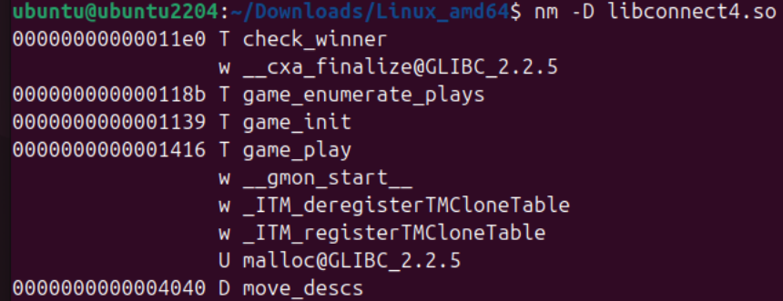
We can see the functions check_winner, game_enumerate_play, game_init, game_play and there is a global variable called move_descs. These are functions that we will want to document as an interface. Note that the other exported functions listed here are auto-generated and we will not need to document these to complete this lab

- We set up Ghidra with the gdb debugger running locally to examine the play executable with its shared object libconnect4.so.
- We start with static analysis of the functions, create structures, and make changes to the disassembly to get some basic understanding of the code.
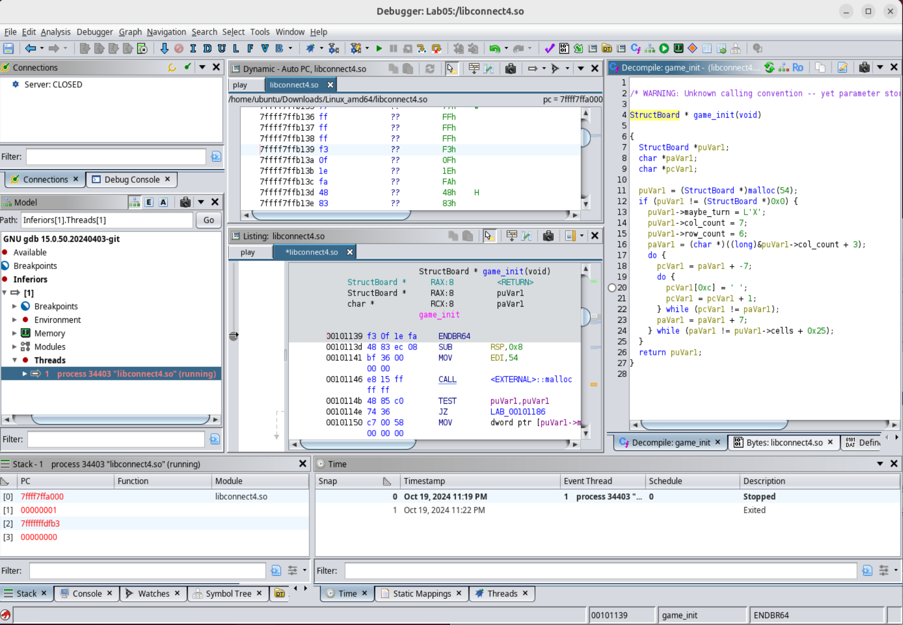

- In parallel, we will create a gdb session for dynamic analysis and set up breakpoints at multiple functions such as game_init, game_enumerate_plays, game_play, and check_winner to understand the flow of the program and see how the data is being populated inside the program.
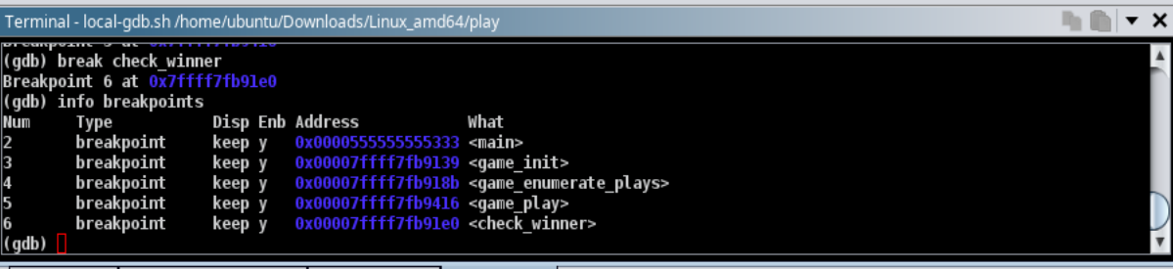

- As we step through each function, we will document the function signature in a header file.

Structure of the API:

1. Overview
The game.h header file defines the core functionalities required to implement a Connect Four game. It provides structures and function declarations used to initialize the game, manage player turns, validate moves, and determine the game outcome (win, draw, or ongoing).

2. Structure Definitions
StructBoard
This structure stores the state of the game, including the current player's turn, the dimensions of the game board, and the contents of each cell.
- turn: Indicates which player's turn it is (1 for Player 1, 2 for Player 2).
- col_count: The number of columns in the cell array (7 in a standard Connect Four game).
- row_count: The number of rows in the cell array (6 in a standard Connect Four game).
- cells: A 6x7 grid that stores the state of the game board. Each cell is represented by a character: 'X' for Player 1, 'O' for Player 2, or ' ' for an empty cell. Note that in the header file that we compiled with our tictactoe.c file, we changed the size of cells[][] so that it had the matching dimensions of a tic-tac-toe board (3 x 3).

3. Function Declarations
- game_init
Function definition: StructBoard* game_init(void);
This function allocates memory and initializes a new game board. It is the caller's responsibility to free the allocated memory when the game is over.
- Return: A pointer to the newly created game board.

- PrintPlay Callback
Function definition: typedef void (*PrintPlay) (int play_id, char* desc, void* user);
A function pointer type that acts as a callback to receive information about an available play. This is used in conjunction with the game_enumerate_plays function.
- play_id: Index representing the column number.
- desc: A user-readable description of the play (retrieved from the move_descs array).
- user: A user-defined pointer that can be passed into the callback for context.

- game_enumerate_plays
Function definition: void game_enumerate_plays(StructBoard* board, PrintPlay print_play, void* user_data);
This function enumerates all valid moves that can be made on the current board. It checks each column to determine if there is space available to place a piece. For each valid move, it calls the PrintPlay callback function.
- board: Pointer to the game board.
- print_play: A callback function to receive the valid move information.
- user_data: A pointer to user-defined context data passed to the callback function.

- game_play
Function definition: int game_play(StructBoard* board, int play_id);
Attempts to place the current player's piece in the specified column. If the move is valid, the game state is updated, the current player's turn changes, and the game checks for a winner.
- board: Pointer to the game board.
- play_id: The column number (0 to col_count - 1) where the piece should be placed.
- Return:
  - ASCII value of the winner ('X' or 'O') if a winning move is made.
  - -1: Invalid move (e.g., column full or out of bounds).
  - 0: Move successful, game continues.
  - -2: Move results in a draw.
  - '?': Error in turn management.

- check_winner
Function definition: int check_winner(StructBoard* board);
This function checks the board for any winning conditions, which include horizontal, vertical, and diagonal (both rising and falling) sequences of four matching pieces. It also checks for a draw condition.
- board: Pointer to the game board.
- Return:
  - ASCII value of the winning player’s symbol ('X' or 'O') if a winner is found.
  - 0: Game is still in progress (empty spaces exist).
  - -2: Game is a draw (board is full with no winner).

4. Notes
- The game board is represented in a 6x7 grid, and moves are made by placing 'X' or 'O' characters in the lowest available position within a chosen column.
- The move_descs[] array contains descriptions of the moves, which are passed to the PrintPlay callback function during the move enumeration.
- The game ends when a player creates a sequence of 4 pieces in a row, either horizontally, vertically, or diagonally, or if the board is filled, resulting in a draw.

Forward Engineering

- After documenting the API and creating the appropriate header file, we need to create an API that would play tic-tac-toe instead of connect4.
- We can use the connect4 header file as a starting point for our new API. We need to make the following change for the tic-tac-toe header file:
    - The board is now 3x3 instead of 6x7. This will accurately reflect the size of the tic-tac-toe game board and will correctly print the board to the console.
- We will create a new c file called tictactoe.c which will make use of the newly created header file tictactoe.h.
- To implement the correct functionality of tic-tac-toe, we will rework the following functions in our new program:
  - Move_descs[]: Naturally, the move descriptions of all moves that can be made during a turn of tic-tac-toe are different than the possible moves that can be made in connect4. This array is populated with updated descriptions of moves that can be made in tic-tac-toe.
  - game_play(): The main difference in game play between connect4 and tic-tac-toe is that pieces are dropped in columns in connect4 while individual board slots can be selected in tic-tac-toe. To implement this, we mapped the variable play_id to put a piece in 1 of 9 different spots on the board, and pieces are placed through the execution of a switch statement.
  - check_winner():The winning condition is modified to check the connection of three ‘X’s or ‘O’s along a row, column, or the two possible diagonals.
- We compile the newly created tictactoe.c file with gcc to create a shared object file called tictactoe.so using the command “gcc -shared -fPIC -o tictactoe.so tictactoe.c”.
- We will replace the existing libconnect4.so with tictactoe.so using “mv tictactoe.so libconnect4.so”.
- We can test the functionality of the API by running play.exe and verifying the functionality of the API.
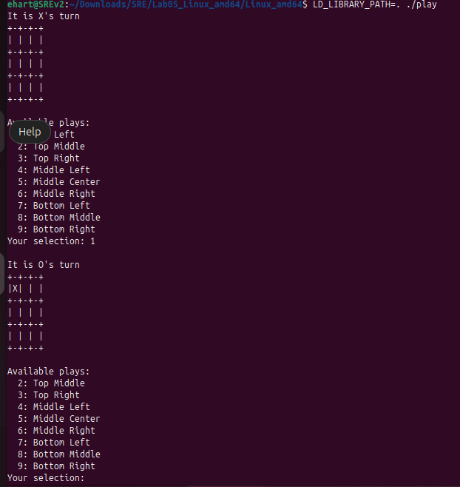

Conclusion:
In this lab, we successfully reverse engineer an undocumented API by doing static analysis and dynamic analysis of the API and created a detailed header file for the API which can be used by other developers to understand the structure of the program. We also created our own API which uses the existing executable and runs tic-tac-toe instead of connect4.

